PRODUCT INFORMATION FILE*

RégimA

Urban Stress Protect + Detox Clarifying Masque

Prepared: September 2018
(Label & packaging update August 2021)

*As required under Article 11 of the European Cosmetics Regulation EC No. 1223/2009
TABLE OF CONTENTS

Contents
INTRODUCTION 3
PRODUCT DESCRIPTION 3
COSMETIC PRODUCT SAFETY REPORT 7
Part A: Cosmetic Product Safety Information 7
A.1 Quantitative and qualitative composition of the cosmetic product: 7
A.2 Physical /chemical characteristics and stability of the cosmetic product 11
A.3 Microbiological Quality 12
A.4 Impurities, traces, information about the packaging material 12
A.5 Normal and reasonably foreseeable use 12
A.6 Exposure to the Cosmetic Product 12
A.7 Exposure to the Substances 13
A.8 Toxicological Profile of the Substances 15
A.9 Undesirable Effects and Serious Undesirable Effects 19
A.10 Information on the Cosmetic Product 19
B: Part Cosmetic Product Safety Assessment 20
B.1 Assessment Conclusion 20
B.2 Label Warnings and Instructions for Use 20
B.3 Reasoning 21
B.4 Assessors Credentials and Approval of Part B 21
List of References 21
METHOD OF MANUFACTURE / GMP CERTIFICATION 22
PROOF OF EFFECT CLAIMED 23
ANIMAL TESTING STATEMENT 23
Appendix 1: Safety Data Sheets or Ingredient Specifications 24
Appendix 2: Microbial Challenge Test 25
Appendix 3: Certificates of Allergen Content 26
Appendix 4: Miscellaneous 27

INTRODUCTION

PRODUCT DESCRIPTION

Product Name: Urban Stress Protect + Detox Clarifying Masque

Product type | Face Clarifying Masque
Form | Light cream
Colour | Off white
Pack size | 150 ml (5 fl oz)
Pack type | Polypropylene
Dispenser type | Airless container
Part of a set | No
Manufacturer code | DCFM 002
Normal use | Directions: Cleanse with RégimA, apply a thin layer of Masque with fingertips to face and neck, avoiding the eye area. Allow 15-20 minutes for penetration and action. Remove thoroughly with RégimA cleanser. Follow with appropriate RégimA after treatment products

Pictures of the Item: On following page

Container label

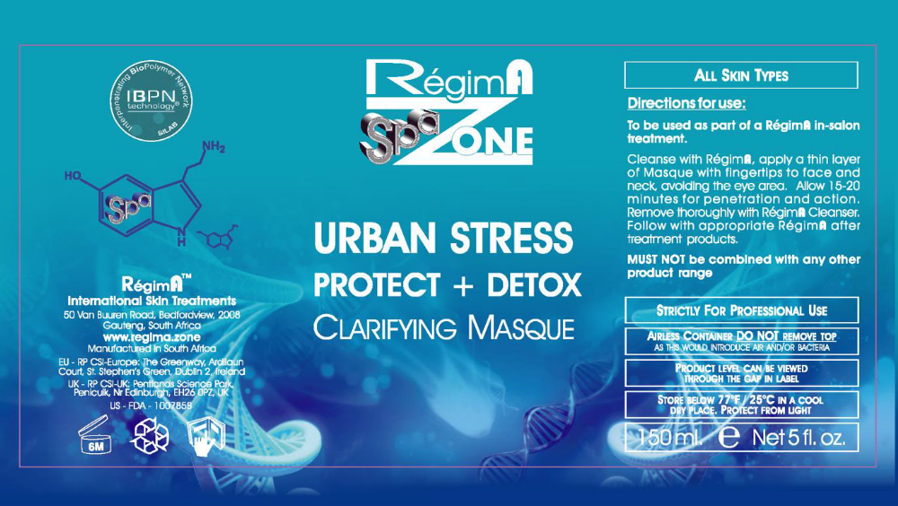
Carton label

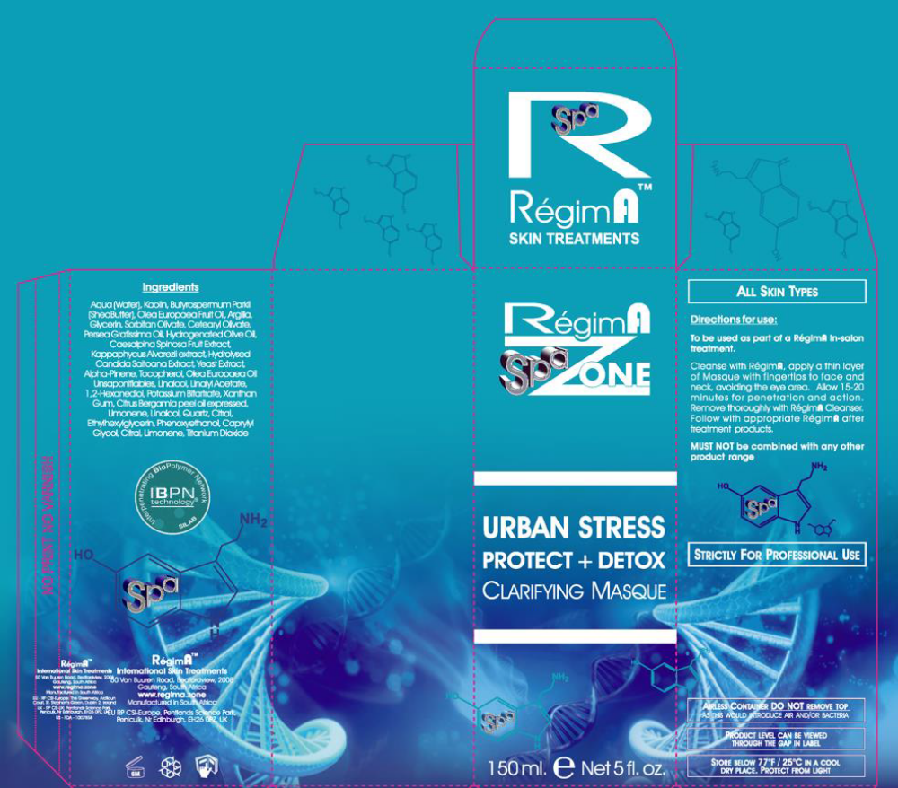
Batch code: The batch number is printed onto the underside of the carton and the container at the point of manufacturing and filling, therefore it is not visible on the label as represented in this PIF. The batching is automated, so the batch code and date is printed onto the carton and container as they are filled and boxed.

Product claims:

This product has no direct claims.

COSMETIC PRODUCT SAFETY REPORT

Part A: Cosmetic Product Safety Information

A.1 Quantitative and qualitative composition of the cosmetic product:

Urban Stress Protect +Detox Clarifying Masque base formula

No | Raw Ingredient (INCI Name) | % (w/w) | Mixture % w/w Wt(g/kg) | CAS | EC | Function | Supplier (Agent) | Tradename
1 | Kaolin | 15 | 15 | 1332-58-7 | 310-194-1 | Abrasive/  Absorbent/  Anticaking/  Bulking/  Cosmetic Colourant/  Opacifying | Protea | Kaolin (Clay Mineral)
2 | Butyrospermum Parkii Butter | 5 | 5 | 194043-92-0/  91080-23-8/  68920-03-6 | 293-515-7/  272-911-3 | Skin Conditioning/  Viscosity Controlling | BASF (Chemgrit) | Cetiol® SB 45
3 | Argilla | 4.675 | 5 | 12199-37-0 | 235-374-6 | Abrasive/  Bulking/  Humectant/  Opacifying/  UV Absorber/  UV Filter/  Buffering | Vanderbilt (IMCD) | Veegum® Ultra
3 | Titanium Dioxide | 0.15 | 5 | 13463-67-7 | 236-675-5 |  | Vanderbilt (IMCD) | Veegum® Ultra
3 | Potassium Bitartrate | 0.15 | 5 | 868-14-4 | 212-769-1 |  | Vanderbilt (IMCD) | Veegum® Ultra
3 | Quartz | 0.025 | 5 | 14808-60-7 | 238-878-4 |  | Vanderbilt (IMCD) | Veegum® Ultra
4 | Cetearyl Olivate | 2.5 | 5 | 85116-80-9 | 285-532-3 | Emulsifying | B&T Srl (Millchem) | Olivem® 1000
4 | Sorbitan Olivate | 2.5 | 5 | 223706-40-9/  92202-01-2 | 296-033-5 | Emulsifying | B&T Srl (Millchem) | Olivem® 1000
5 | Olea Europaea Fruit Oil | 4 | 4 | 8001-25-0 | 232-277-0 | Masking/  Perfuming/  Skin conditioning | Textron Technica (CJP Chemicals) | Olive Oil Extra Virgin
6 | Glycerin | 4 | 4 | 56-81-5 | 200-289-5 | Humectant/  Perfuming/  Skin Protecting/  Viscosity Controlling | Organic Chemical Corporation | Refined Glycerine
7 | Hydrogenated Olive Oil | 1.803 | 3 | 226993-75-5/  68334-28-1 | 269-820-6 | Skin Conditioning/  Viscosity Controlling/  Masking/  Skin Conditioning | B&T Srl (Millchem) | Oliwax
7 | Olea Europaea Fruit Oil | 0.9 | 3 | 8001-25-0 | 232-277-0 |  | B&T Srl (Millchem) | Oliwax
7 | Olea Europaea Oil Unsaponifiables | 0.297 | 3 | 8001-25-0/  156798-12-8 | 232-277-0 |  | B&T Srl (Millchem) | Oliwax
8 | Water (Aqua) | 2.8665 | 3 | 7732-18-5 | 231-791-2 | Skin Conditioning/  Solvent /  Skin Protecting/  Preservative | Silab (Meganede) | Celldetox®
8 | Hydrolysed Candida Saitoana Extract | 0.1125 | 3 | 1151559-87-3 | 232-387-9 |  | Silab (Meganede) | Celldetox®
8 | Phenoxyethanol | 0.015 | 3 | 122-99-6 | 204-589-7 |  | Silab (Meganede) | Celldetox®
8 | Ethylhexylglycerin | 0.006 | 3 | 70445-33-9 | 408-080-2 |  | Silab (Meganede) | Celldetox®
9 | Water (Aqua) | 2.874 | 3 | 7732-18-5 | 231-791-2 | Solvent/  Skin Conditioning/  Skin Protecting/  Emollient/  Humectant/ | Silab (Meganede) | Mitokinyl®
9 | Yeast Extract | 0.096 | 3 | 8013-01-2/  68876-77-7 | 232-387-9 |  | Silab (Meganede) | Mitokinyl®
9 | 1,2-Hexanediol | 0.015 | 3 | 6920-22-5 | 230-029-6 |  | Silab (Meganede) | Mitokinyl®
9 | Caprylyl Glycol | 0.015 | 3 | 1117-86-8 | 214-254-7 |  | Silab (Meganede) | Mitokinyl®
10 | Persea Gratissima Oil | 2 | 2 | 8024-32-6 | 232-428-0 | Skin Conditioning | Textron Technica (CJP Chemicals) | Avocado Oil
11 | Phenoxyethanol | 0.901 | 1 | 122-99-6 | 204-589-7 | Preservative /  Emollient/  Humectant/  Skin Conditioning | Dr Straetmans (Meganede) | Verstatil® PC
11 | Caprylyl Glycol | 0.099 | 1 | 1117-86-8 | 214-254-7 | Preservative /  Emollient/  Humectant/  Skin Conditioning | Dr Straetmans (Meganede) | Verstatil® PC
12 | Xanthan Gum | 0.8 | 0.8 | 11138-66-2 | 234-395-2 | Binding/  Emulsifying/  Emuslion Stabilising/  Gel Forming/  Skin Conditioning/  Surfactant/  Viscosity Controlling | CP Kelco( Tranarc) | Keltrol T-Plus
13 | Citrus bergamia peel oil expressed  (also known as the perfuming name: Citrus Reticulata, X C. Sinensis Peel Extract) | 0.5 | 0.5 | 93686-22-7 | 297-672-2 | Perfuming | FD Copeland (CJP Chemicals) | Bergamot Oil
14 | Kappaphycus Alvarezii extract | 0.19 | 0.4 | 1220882-73-4 | 310-127-6 | Skin Protecting/  Skin Conditioning/  Solvent | Silab (Meganede) | Filmexel ®
14 | Caesalpinia Spinosa Fruit Extract | 0.19 | 0.4 | 39300-88-4 | 254-409-6 | Skin Protecting/  Skin Conditioning/  Solvent | Silab (Meganede) | Filmexel ®
14 | Water (Aqua) | 0.02 | 0.4 | 7732-18-5 | 231-791-2 | Skin Protecting/  Skin Conditioning/  Solvent | Silab (Meganede) | Filmexel ®
15 | Tocopherol | 0.1 | 0.1 | 54-28-4(gamma)/  16698-35-4 (beta)/  10191-41-0(DL)/  119-13-1/  1406-18-4/  1406-66-2/  2074-53-5 (DL)/  59-02-9/  7616-22-0 | 200-201-5/  240-747-1/  233-466-0/  204-299-0/  215-798-8/  218-97-9/  200-412-2 | Antioxidant/  Masking/  Skin Conditioning | DSM Nutrient Products  (chempure) | dl-α- Tocopherol
16 | Water (Aqua) | 43.2 | 48.2 | 7732-18-5 | 231-791-2 | Solvent | Inhouse | Deiolinsed water
# not assigned

Ingredient order for the label: Water(Aqua), Kaolin, Butyrospermum Parkii Butter, Olea Europaea Fruit Oil, Argilla, Glycerin, Sorbitan Olivate, Cetearyl Olivate, Persea Gratissima Oil, Hydrogenated Olive Oil, Phenoxyethanol, Xanthan Gum, Citrus bergamia peel oil expressed, Olea Europaea Oil Unsaponifiables, Caesalpina Spinosa Fruit Extract, Kappaphycus Alvarezii extract, Potassium Bitartrate, Titanium Dioxide, Limonene, Caprylyl Glycol, Hydrolysed Candida Saitoana Extract, Tocopherol, Yeast Extract, Linalool, Quartz, Citral, 1,2-Hexanediol, Ethylhexylglycerin, Citral, Limonene, Linalool, Linalyl Acetate, Alpha-Pinene.

Red font denotes ingredients present at less than 1% which may be listed in any order.
Below are the allergens and their respective concentrations in the fragrance that are required to be listed in Article 19 Paragraph 1(d) & (g (ii)) of EC 1223/2009 when present at levels >0.001% in a leave-on product.

Fragrance allergens

INCI (EU) Name | CAS number | EC number | Concentration % w/w | Comment
Citral | 5392-40-5 | 226-394-6 | 0.01505 | Annex III/70*
Limonene | 5989-27-5 | 227-813-5 | 0.1368 | Annex III/88*
Linalool | 78-70-6 | 201-134-4 | 0.05025 | Annex III/84*
Linalyl Acetate | 115-95-7 | 204-116-4 | 0.26895 | SCCS opinion on fragrances 2*
Alpha-pinene | 80-56-8 | 201-291-9 | 0.0145 | SCCS opinion on fragrances 2*
* Regulation (EC) No 1223/2009 of the European Parliament and of the council of 30 November 2990 on cosmetic products, Annex III; List of substances which cosmetics products must not contain except subject to the restrictions laid down.
2* SCCS opinion on Fragrance allergens in Cosmetic products, 15th plenary meeting, June 2012, Section 7, Table 7-1, Page 47.

A.2 Physical /chemical characteristics and stability of the cosmetic product

Physical and chemical characteristics of the ingredients have been listed in the safety data sheets which are maintained electronically by the Responsible Person and are available on request. A cross reference to the SDS tradename and electronic reference number has been shown in the base formula table, Section 7, Table 7-1, page 47.

Physical and Chemical Characterization of the product

1 Physical state | Cream
2 type of mixture (emulsion/ o/w or w/o, suspension, lotion, powder, aerosol …) | Lotion
3 organoleptic properties (colour, odour, whenever relevant) | Off white colour with characteristic odour
4 pH (at 25ºC) | 4.24
5 viscosity (at 25ºC ) | 89 500 cPs
6 thermal stability (glass bottle) | 50 ºC for 12 weeks
7 Specific gravity (at 25ºC ) | 0.987/ml

Stability of the product

A shelf-life of 6months after opening has been allocated to this product.

An on-going stability study of the product in the packaging will be available to support the shelf-life. A stability test of the product in glass jars has confirmed stability at 25ºC for 12 weeks.

Accelerated stability testing was performed at 40 and 50 ºC for 12 weeks which further substantiated the product was stable as formulated. A reduction in viscosity was however noted across all the temperature ranges in the stability tests in week 12; 59%, 51%,77%,68% in 5 ºC, 25 ºC, 40 ºC and 50 ºC respectively. This reduction in viscosity in all stability test is not expected to affect the overall stability of the product as formulated.

A.3 Microbiological Quality

A PET test has been performed according to USP method 38 and confirms the effectiveness of the preservative for a period of 28 days. The certificate has been presented in Appendix 2.

A.4 Impurities, traces, information about the packaging material

None of the ingredients of this product contained impurities at a level which would require notification.

A statement on the suitability of the product packaging is shown below.

The Chubby Chunky Airless Container is made from Polypropylene. The pump is made from Polypropylene, high-density polypropylene and low-density-polypropylene. The components of the packaging material and specifications are included in a certificate in Appendix 4. This is maintained electronically with the PIF by the Responsible Person and is available on request.

A.5 Normal and reasonably foreseeable use
Urban Stress Protect + Detox Clarifying Masque is a product designed clarify the skin. It is a wash off product that in normal circumstances will be used twice daily on the face and neck (avoiding the eye area).

A.6 Exposure to the Cosmetic Product

Site of application | Face and neck
Surface area of application (cm²) | 885*
Volume of product applied (mg) | 250
Frequency of application/use per day | 1**
Target population | Adults
Normal and foreseeable exposure route | Dermal
Calculated relative daily exposure according to SCCS notes for guidance tables (mg/kg bw/day) | 0.5ml exposure daily  Estimated exposure based on 60 kg adult =  4.17 mg/kg bw/day
Dermal absorption information | None
other | NA
*The total surface area the Urban Stress Protect + Detox Clarifying Masque is applied too= 885cm² (Skincare: 565cm²- Face surface area + 320cm² -Neck surface area). The figures used are adapted from SCCS Notes of the Guidance for the testing of Cosmetic Ingredients and their Safety Evaluation, 9th Revision, Section 4.2, Table 1, page 76
** The frequency of application for Urban Stress Protect + Detox Clarifying Masque was determined as 1 applications per day, this was determined due to the product sole use ‘In Salon’ where it is applied by professionals trained by RégimA. A warning is in place on the label to indicate it’s in salon use only.

A.7 Exposure to the Substances

Daily Systemic Exposure Dosage (SED) is the daily amount of a cosmetic substance applied based on the concentration of that particular substance, the percutaneous absorption and the nominal human body weight (60 kg) and this is shown in the table below.
Ingredient  (INCI name & CAS number) | Maximum concentration  (%) | Calculated product relative daily exposure (mg/kg bw/day) | Dermal penetration factor# | Daily ingredient exposure or SED  (mg/kg bw/day)
Kaolin  1332-58-7 | 15 | 4.17 | 0.01 | 0.00626
Butyrospermum Parkii Butter  194043-92-0 | 5 | 4.17 | 0.01 | 0.00209
Olea Europaea Fruit Oil  8001-25-0 | 4.9 | 4.17 | 0.01 | 0.00204
Argilla  12199-37-0 | 4.675 | 4.17 | 0.01 | 0.00195
Glycerin  56-81-5 | 4 | 4.17 | 0.01 | 0.00167
Sorbitan Olivate  223706-40-9 | 2.5 | 4.17 | 0.01 | 0.00104
Cetearyl Olivate  85116-80-9 | 2.5 | 4.17 | 0.01 | 0.00104
Persea Gratissima Oil  8024-32-6 | 2 | 4.17 | 0.01 | 0.00083
Hydrogenated Olive Oil  226993-75-5 | 1.803 | 4.17 | 0.01 | 0.00075
Phenoxyethanol  122-99-6 | 0.916 | 4.17 | 0.01 | 0.00038
Xanthan Gum  11138-66-2 | 0.8 | 4.17 | 0.01 | 0.00033
Citrus bergamia peel oil expressed  (also known as the perfuming name: Citrus Reticulata, X C. Sinensis Peel Extract) | 0.5 | 4.17 | 0.01 | 0.00021
Olea Europaea Oil Unsaponifiables  8001-25-0 | 0.297 | 4.17 | 0.01 | 0.0001238
Caesalpina Spinosa Fruit Extract  39300-88-4 | 0.19 | 4.17 | 0.01 | 0.0000792
Kappaphycus Alvarezii extract  1220882-73-4 | 0.19 | 4.17 | 0.01 | 0.0000792
Potassium Bitartrate  868-14-4 | 0.15 | 4.17 | 0.01 | 0.0000626
Titanium Dioxide  13463-67-7 | 0.15 | 4.17 | 0.01 | 0.00006255
Caprylyl Glycol  1117-86-8 | 0.114 | 4.17 | 0.01 | 0.00004754
Hydrolysed Candida Saitoana Extract  1151559-87-3 | 0.1125 | 4.17 | 0.01 | 0.00004691
Tocopherol  54-28-4 | 0.1 | 4.17 | 0.01 | 0.00004170
Yeast Extract  8013-01-2 | 0.096 | 4.17 | 0.01 | 0.00004003
Quartz  14808-60-7 | 0.025 | 4.17 | 0.01 | 0.00001043
1,2-Hexanediol  6920-22-5 | 0.015 | 4.17 | 0.01 | 0.00000626
Ethylhexylglycerin  70445-33-9 | 0.006 | 4.17 | 0.01 | 0.00000250
# 1% dermal absorption is used in the assessment of Urban Stress Protect +Detox Clarifying Masque. The dermal penetration factor was obtained from Face washes, gels and scrubs, Table 3, Dermal sensitization quantitative risk Assessment (QRA) for fragrance ingredients, Api et al, 2007.

A.8 Toxicological Profile of the Substances
Ingredient  (INCI name & CAS number) | Hazard ID and listª | Reference for hazard ID | Irritant to eyes | Irritant to skin | Sensitiser | Human data | NOAEL  (mg/kg bw/day) | SED^{b} | MoS^{c} | comment
Kaolin  1332-58-7 | A | 2014 CIR Compendium. For use up to 100%, IJT 28(S1):37-102, 2003.
Butyrospermum Parkii Butter  194043-92-0 | A | 2014 CIR Compendium. For use up to 60%, Final report 03/11 available from CIR
Olea Europaea Fruit Oil  8001-25-0 | A | 2014 CIR Compendium. For use up to 100%, Final report 03/11 available from CIR
Argilla  12199-37-0 | B | An additional assessment was performed on Argilla. Argilla is described as naturally occurring substance in the Smectite group minerals with cosmetic functions including; abrasive, bulking and humectant properties. Argilla has been adopted as a trade name for ‘Kaolin’; World Health Organisation, W. (2005). Bentonite, Kaolin and Selected Clay Minerals (EHC 231, 2005). [online] Inchem.org. Available at: http://www.inchem.org/documents/ehc/ehc/ehc231.htm#3.2.1.3 [Accessed 3 Sep. 2018], a read across was then performed to Kaolin. 204 CIR Compendium. For use up to 100%, IJT 22(S1):37-102, 2003.
Glycerin  56-81-5 |  | Safe, GRAS, FDA approved food additive, FDA approved over the counter (OTC) for skin
Sorbitan Olivate  223706-40-9 | A | 2014 CIR Compendium. For use up to 7.5%, IJT 21(S1):93-112, 2002
Cetearyl Olivate  85116-80-9 | A | 2014 CIR compendium, safe for use in cosmetics when formulated to be non-irritating, Final report 03/2013 available from CIR.
Persea Gratissima Oil  8024-32-6 | A | 2014 CIR Compendium. For use up to 98%, Final amended report 03/11 available from CIR; JEPT 4(4):93-103, 1980 (original) re-review IJT 22(S1):1-35, 2003.
Hydrogenated Olive Oil  226993-75-5 | A | 2014 CIR Compendium. For use up to 12%, Final report available from CIR.
Phenoxyethanol  122-99-6 | A | 2014 CIR Compendium. For use up to 1%, JACT 9(2):259-77, 1990.
Xanthum Gum  11138-66-2 | A | 2014 CIR Compendium. For use up to 6%, Final report 09/12 available from CIR.
Olea Europaea Oil Unsaponifiables  8001-25-0 | A | 2014 CIR Compendium. For use up to 3%, Final report 03/11 available from CIR.
Caesalpinia Spinosa Fruit Extract  39300-88-4 | 2# | A secondary assessment was performed on Caesalpinia Spinosa Fruit extract, where a read across to Caesalpinia spinosa gum as performed. A typical dose range was established as being from 1-5%; Caesalpinia Spinosa Fruit extract is present in formulation at 0.19% (0.0000792 mg/kg bw/day), 5.26 times less than the worst case scenario dose. JECFA opinion on ‘Tara’ Gum (obtained from grinding the endosperm of the seeds of Caesalpinia spinosa; family: Leguminosae) declared Caesalpinia Spinosa Fruit extract safe for use as food ingredient with no ADI specified for man. It was then concluded that Caesalpinia Spinosa Fruit extract is safe for use in Urban Stress Protect + Detox clarifying Masque as formulated. The secondary assessment is presented in Appendix 4
Kappaphycus Alvarezii extract  1220882-73-4 | 2# | A secondary assessment was performed on Kappaphycus alvarezii extract where a read across was performed to Carrageenan; the read across was performed as the sulphated galactans present primarily in Kappaphycus Alvarezii are known as Carrageenan. Carrageenan is a large macro-molecule with ranging molecular weights of 200,000-400,000 resulting in low risk dermal penetration. Carrageenan was determined as GRAS by the US FDA and therefore safe for use in Urban Stress Protect + Detox Clarifying Masque at 0.19% (0.0000792 mg/kg bw/day) . See attached secondary assessment in Appendix 4.
Potassium Bitartrate  868-14-4 | B | Determined GRAS by the FDA, referenced as Potassium Acid Tartrate. 21CFR184.1077
Titanium Dioxide  13463-67-7 | B | Titanium Dioxide was evaluated by JECFA where an ADI of ‘Not Limited’ was established at the 13th JECFA (1969). TRS 733-JECFA 29/24
Caprylyl Glycol  1117-86-8 | A | 2014 CIR Compendium. For use up to 5%, IJT 31 (S2):147-168, 2012
Hydrolysed Candida Saitoana Extract  1151559-87-3 | 2# | A secondary assessment was performed on Hydrolysed Candida Saitoana Extract; isolated and purified form of Candida Saitoana, a fungus obtained from a fermentation process. The active ingredient in hydrolysed Candida Saitoana Extract has been identified as α-glucans. Limited toxicology data is available for α-glucan so a read across was performed to β-glucan due to the stereochemistry. Β-glucans have a high molecular mass, thus reducing the potential for dermal absorption. During a sub-chronic oral toxicity study a no adverse effect dose of 2.5 g/kg bw/day. A worst case dose for Hydrolysed Candida Saitoana Extract was established at 41.6mg/kg bw/day. This is 888,226 times greater than the level present in Urban Stress Protect + Detox Clarifying Masque, which is 0.00004691 mg/kg bw/day. It was concluded that Hydrolysed Candida Saitoana Extract is safe for use as formulated. The secondary assessment for Hydrolysed Candida Saitoana Extract is present in Appendix 4.
Tocopherol  54-28-4 | A | 2014 CIR Compendium. For use <= 5% IJT 21 (S3):51-116, 2002; Final report 03/2014 available from CIR
Yeast Extract  8013-01-2 | A | Food item (various), GRAS category (FDA) as food for human consumption.
Quartz  14808-60-7 | B | Quartz was assessed under the name Crystalline silica; where quartz is the most common form, Occupational Safety and Health administration (2002). Crystalline Silica Exposure Health Hazard Information. [online] Osha.gov. Available at: https://www.osha.gov/OshDoc/data_General_Facts/crystalline-factsheet.pdf [Accessed 4 Sep. 2018]. According to the FDA Quartz has been identified as Silicon dioxides with a CAS number 14808-60-7 and has been considered as a GRAS substance; SCOGS Report Number: 61, NTIS Accession Number: PB301402, 1979 (FDA (1979). Select Committee on GRAS Substances (SCOGS) Opinion: Silicates. [online] Wayback.archive-it.org. Available at: http://wayback.archive-it.org/7993/20171031063508/https://www.fda.gov/Food/IngredientsPackagingLabeling/GRAS/SCOGS/ucm260849.htm [Accessed 4 Sep. 2018].)
1,2-Hexanediol  6920-22-5 | B | For use up to 10% in dermal contact products. The sensitization potential of 1,2-hexanediol was evaluated at concentrations of 10%, 50% and 10% in acetone/olive (3:1) using the mouse local lymph node assay (following OECD 429 protocol). The results from the study indicated 1,2-Hexanediol was negative for its skin sensitization potential. A 50:50 (w/w) mixture of 1,2-Hexanediol and caprylyl glycol was evaluated in an RIPT involving 56 subjects. The test concentration was set at 20% in gel(where the effective concentration per ingredient equaled to 10%) where it was determined that the mixture did not induce skin sensitization in any of the test subjects. A leg and foot gel containing 0.5% 1,2-Hexanediol was applied to the upper back of 101 healthy subjects (males and females) in an RIPT. The test site was covered with a semi-occlusive patch that remained in place for 24h, The product did not induce skin irritation or sensitization. A safety evaluation on the skin irritation and sensitization potential of 1,2-Hexanediol utilized the in-use effect of a body wash containing 0.15% 1,2-Hexanediol for a minimum of 3 times per week over a total of 30 days. No evidence of erythema, edema or dryness was identified during the test period and it was concluded that the product containing 1,2-Hexanediol did not demonstrate a potential for skin irritation or sensitization. 1,2-Hexanediol is present in Urban Stress Protect + Detox Clarifying Masque at 0.015%; 666 times less than the maximum concentration of 10%, it is determined that the use of 1,2-Hexanediol in cosmetics. Final report ‘On the safety assessment of 1,2-Glycols as used in cosmetics’ June 2011 available from the CIR website.
Ethylhexylglycerin  70445-33-9 | A | 2014 CIR Compendium. For use up to 8%, IJT 32 (S3):5-21, 2013.

ª Some ingredients are excluded from a formal risk assessment where a recognized authority has published a review of the ingredient under similar conditions of use and concluded on safe use at the level of inclusion in the cosmetic product (Hazard ID=A). Hazard ID category B is for recognized authority reviews of the ingredient under similar conditions of use with restricted use or where the ingredient is contained in the annexes to Regulation (EC) No 1223/2009 (Hazard ID=B). Where hazard ID A or B is reported, the maximum allowed usage concentration should be stated.
^{b} all possible routes of exposure should be considered
^{c} A MoS of greater than 100 is considered to represent safe use
# Food item, hazard and exposure data not required.
2# A secondary assessment was performed on this ingredient, reports are placed in Appendix 4.

Fragrances:

Urban Stress Protect + Detox Clarifying Masque does contain a fragrance known as Bergamot Oil. The IFRA certificate and allergen certificate is presented in Appendix 3.

A.9 Undesirable Effects and Serious Undesirable Effects

No undesirable effects are anticipated based on the product being used as directed on the face and neck twice daily.

A.10 Information on the Cosmetic Product

Urban Stress Protect +Detox Clarifying Masque was released in June 2017. Over the period June 2017 to September 2018, 914 units have been sold and there have been no adverse reactions reported to RégimA cosmetics.

B: Part Cosmetic Product Safety Assessment

B.1 Assessment Conclusion

Review of the ingredients

After analysis of all the available information including:
- formulation
- toxicological profile of the ingredients and their concentration in the product
- Product data sheets supplied by the ingredient manufacturer

It is not expected that Urban Stress Protect + Detox Clarifying Masque will cause damage to human health when used as directed.

It is therefore concluded that Urban Stress Protect + Detox Clarifying Masque can placed on the market in the EU as a face masque.

Review of human data on the product

There are no human tests such as a patch test, for this product.

B.2 Label Warnings and Instructions for Use

Directions for use are given on the product label provided in Appendix 4.

Directions: Cleanse with RégimA, apply a thin layer of masque with fingertips to face and neck, avoiding the eye area. Allow 15-20 minutes for penetration and action. Remove thoroughly with RégimA cleanser. Follow with appropriate RégimA after treatment products.

Warnings:

‘Strictly for professional use’

‘Airless Container DO NOT remove top as this would introduce air and/or bacteria’

‘Product level can be viewed through the gap in label’

‘Store below 77°F/25°C in a cool dry place. Protect from light’

‘Must not be combined with any other product range’

‘Avoiding eye area’
B.3 Reasoning

This product contains many ingredients with a positive reputation for their Facial masque properties and with e.g good local tolerance. There are no reasons to anticipate tolerance problems with use.

This product is intended for external use in adults only.

B.4 Assessors Credentials and Approval of Part B

Shirley Hudson (safety assessor)
BSc, University of Aberdeen
CBiol, MSB
20+ years as a practicing toxicologist in the pharmaceutical and chemical industries
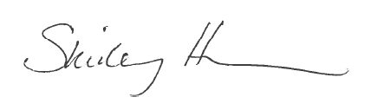

After analyzing of all of the available information including the product formulation and toxicological profile of the ingredients, I conclude that according to the current state of scientific knowledge, this product is not expected to result in any significant damage to human health and can be safely marketed for the intended and foreseeable use as a facial masque.

List of References

SCCS Notes of Guidance for the Testing of Cosmetic Substances and Their Safety Evaluation, 9th Revision, 29 September 2015 (SCCS/1564/15)
European Commission database on cosmetic ingredients (Cosing) http://ec.europa.eu/consumers/cosmetics/cosing/
Cosmetic ingredient review http://www.cir-safety.org/

METHOD OF MANUFACTURE / GMP CERTIFICATION

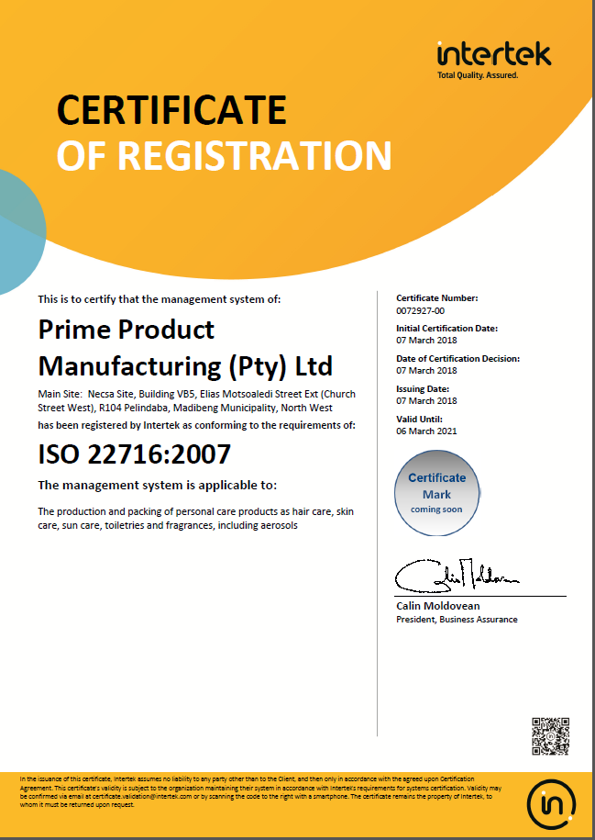

PROOF OF EFFECT CLAIMED

This product makes no direct or implied claims and consequently no proof is required.

ANIMAL TESTING STATEMENT

To the best of our knowledge, the manufacturer and his suppliers have not carried out or commissioned any animal testing for the purpose of developing new cosmetic products.

The statement below is a confirmation of the company policy:

RégimA Skin Treatments
CK92/05371/23
VAT No. 4590131043

Tel: 011 615 2869 or 011 622 7827
Fax: 011 616 8008
Cell: 0836537020
e-mail: jax@regima.com

POSTAL ADDRESS: PO BOX 9523 Edenglen 1613
PHYSICAL ADDRESS: 20 River Road Morninghill Bedfordview 2007 RSA

Animal Testing Compliance Statement

This letter is to serve as testimony as to the practice of animal testing, and confirm that RégimA Skin Treatments has not, nor will not engage in any practice that involves animal testing in any form.

RégimA Skin Treatments hereby confirms neither the manufacturer nor RégimA Skin Treatments itself have commissioned or carried out any form of animal testing during the course of product development. This applies to any and all activities performed as part of the development process, including, but not restricted to: R&D, stability testing, safety and toxicology assessments, suitability studies or any other facet related to the product’s development.

Appendix 1: Safety Data Sheets or Ingredient Specifications

Safety data sheets and technical data sheets for the ingredients are maintained electronically with the PIF by the Responsible Person. They are available on request.

Appendix 2: Microbial Challenge Test
A microbial challenge test is maintained electronically with the PIF by the Responsible Person. It is available on request.

Appendix 3: Certificates of Allergen Content

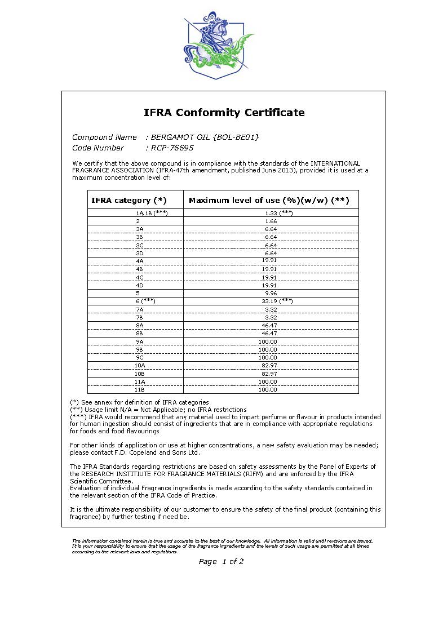
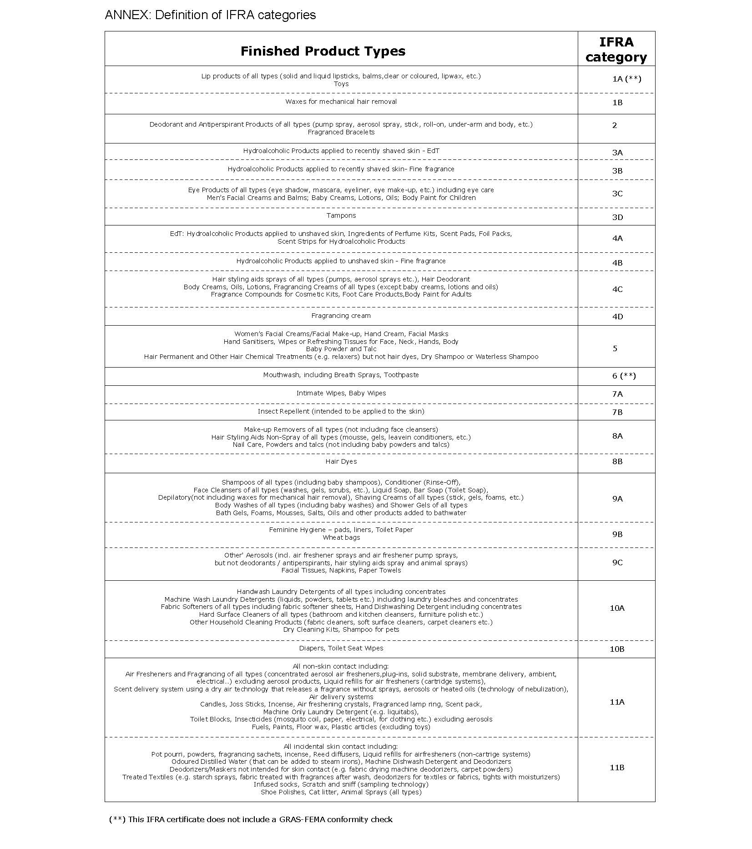
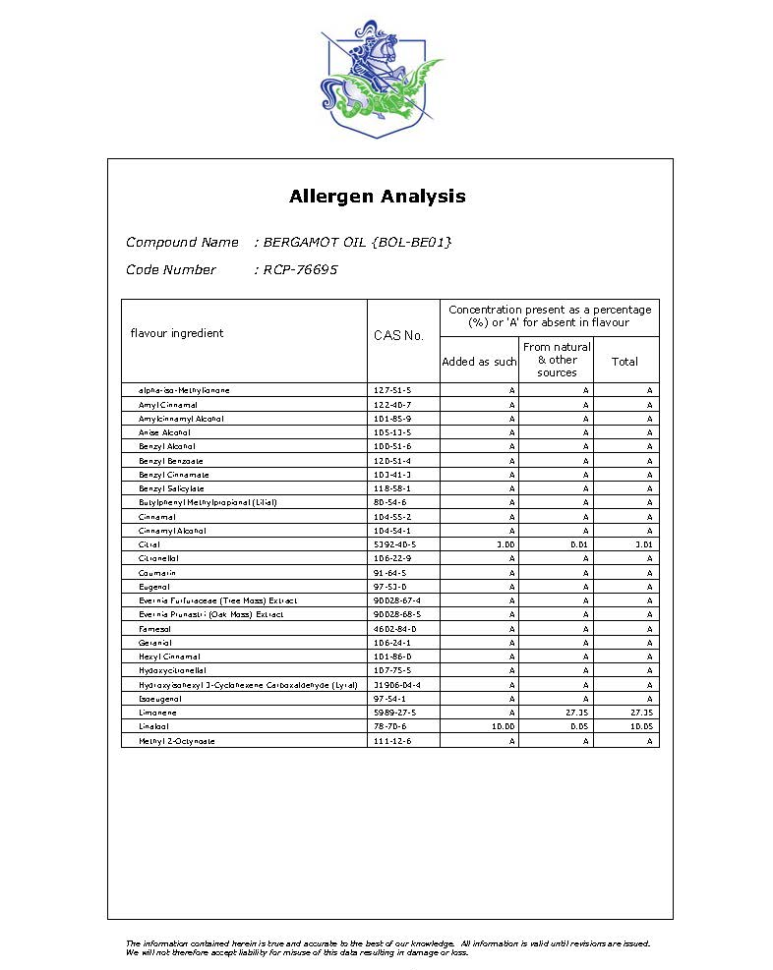

Appendix 4: Miscellaneous

The stability report, packaging material information and product carton insert are maintained electronically with the PIF by the Responsible Person. They are available on request.

